Students and Parents,
Welcome to the H.V. Jenkins School of Engineering! We are going to be your English teachers. Please understand that as Honors courses within the School of Engineering, these courses are designed with three key concepts in mind: Rigor, Balance, and Relevance. We also try to make them fun.
Summer assignments are mandatory, and these two assignments will cover your summer work for your English class. These assignments require more than the average reading log, so if you have any questions at any time during the summer, please email us at Melissa.mccoy@sccpss.com or Amanda.feldmann@sccpss.com. Do not wait until the last minute to contact us about these summer assignments.
You will be reading and annotating one book over the summer, and you will choose your book from the list below. The list includes both fiction and non-fiction, we really encourage you to look into the books and find one that you’ll enjoy. (Read: don’t just pick the shortest one.)
For best results, you will need to purchase your own copy of these texts. They are available on Amazon, half.com (this is where we get most of our books), and through Kindle or other e-readers.
If you are unable to purchase a copy of a book for legitimate reasons, please contact us immediately via email at Melissa.mccoy@sccpss.com or Amanda.feldmann@sccpss.com, and we will work to procure a copy of the book for you. Do not wait until the last minute, because your assignments are due the day we come back from summer break.
Do not fall into the trap of thinking you can muddle your way through this assignment based on the internet. Your assignments depend on reading deeply and extracting meaning. Please review the assignment sheets carefully.
List of books!
- Shipbreaker, Paolo Bacigalupi
- Feed, M.T. Anderson
- Me & Earl & the Dying Girl, Jesse Andrews
- Simon vs. the Homosapiens Agenda, Becky Albertalli
- Eleanor & Park, Rainbow Rowell
- How Soccer Explains the World, Franklin Foer
- We Were Liars, E. Lockhart
- I’ll Give You the Sun, Jandy Nelson
- Rash, Pete Hautman
- Little Brother, Cory Doctorow
- Winger, Andrew Smith
- How It Went Down, Kekla Magoon
- Code Name Verity, Elizabeth Wein
- The Sun Is Also a Star, Nicola Yoon

Assignment #1: Double-Entry Response Journal
Step 1: Purchase a copy of your book from any bookstore or online retailer.
Step 2: As you read, complete a response journal that includes a minimum of 25 entries. Your journal must include entries for the following (the template for this double-entry response journal is at the end of this summer reading packet):
- Characterization:
  - One entry per main character
  - Discuss the character’s appearance, personality, and importance to the overall plot.
- Symbols:
  - Choose two recurring symbols and explain what they represent.
- Examples of Figurative Language (metaphor, simile, personification, etc.)
  - Post five examples of figurative language.
  - You can mix and match your elements, but do not just post the example; explain why you chose to highlight that particular example.
Step 3: Turn this in on the first day of class. It can be either handwritten or typed.
Assignment #2: Infographic Assignment
Step 1: Purchase a copy of your second book from any bookstore or online retailer.
Step 2: Read and annotate the book. (Clearly.)
Step 3: Create an infographic about the book that explores some of the major themes, details, protagonist’s problems and solutions, and other evidence from this book. By searching “infographic tools” you will find a bunch of different online tools to create your infographic.
Step 4: Email us the link or print out your infographic and turn it in. This will be worth a major assessment grade.
As always, if you have any problems or questions before the first day of school, do not hesitate to contact us. We will be checking email all summer and will be available to help answer any questions or problems you have as you work on the assignments.
We are super excited to be working with you next year! Now go get those books, hit the beach, and start reading.
Mrs. McCoy and Ms. Feldmann

RUBRIC FOR INFOGRAPHIC
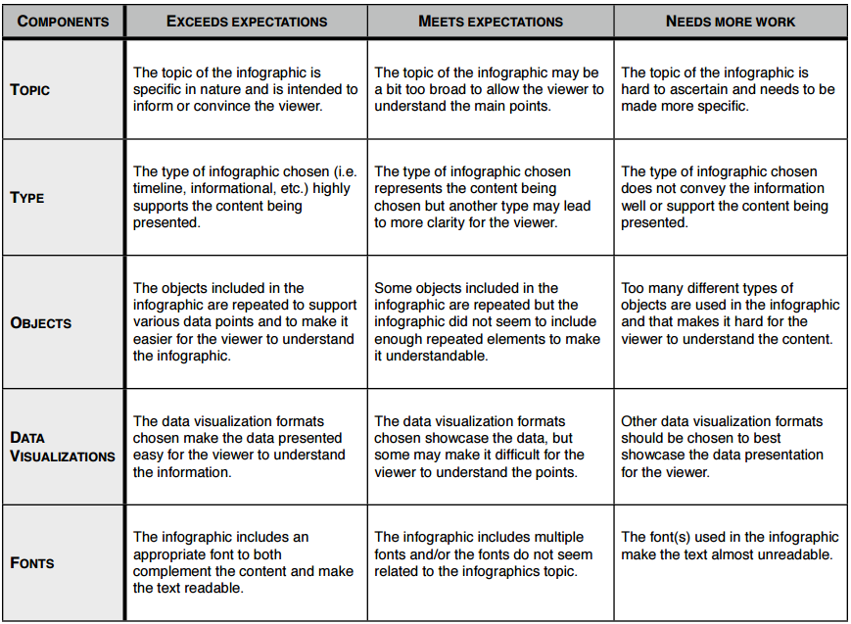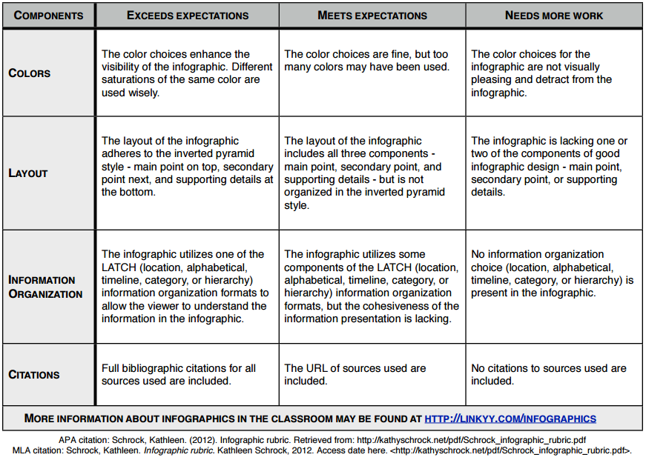

DOUBLE-ENTRY RESPONSE JOURNAL TEMPLATE
FROM THE TEXT | ANALYSIS/COMMENTARY
On the left-hand column, write specific quotes WORD FOR WORD from the book. These selections of evidence from the text can include:  - Any quote you find interesting or have an insight about  - An example of figurative language (metaphor, simile, personification, hyperbole, etc.)  - An example of satire  - An interesting or new word within the sentence in which it appears  - A quote that touches on one of the universal themes within the text  Number each entry. In parenthesis after each entry, write the page number where you found the quote.  Examples:  - From the NOTICE: “Persons attempting to find a motive in this narrative will be prosecuted; persons attempting to find a moral in it will be banished; persons attempting to find a plot in it will be shot.” (p. 9)  - When Mrs. Watson doesn’t allow Huck to smoke, he says, “And she took snuff, too; of course that was all right, because she done it herself.” (p. 12) | On the right-hand column, write:  - A response to or a reflection on what you wrote in the left-hand column  - The definition of the word you didn’t know  - A comment on how the use of figurative language enhances the text  - A comment on what the author is satirizing and what he’s criticizing  - A comment on one of universal themes in the book  - A question to bring up in class about something you might not understand  - A personal response to a specific selection of text  - Is Mark Twain trying to use reverse psychology here to make us look for motive, moral, and plot?  - Mrs. Watson is so religious so pious, but it seems like she is a bit of a hypocrite. How will Huck ever want to follow in her footsteps when he’s witness to her hypocrisy?

Making Annotations: A User’s Guide

As you work with your text, consider all of the ways that you can connect with what you are reading. Here are some suggestions that will help you with your annotations:
- Define words or slang; make the words real with examples from your experiences; explore why the author would have used a particular word or phrase.
- Make connections to other parts of the book. Feel free to use direct quotes from the book.
- Make connections to other texts you have read or seen, including: movies, comic books/graphic novels, news events, other books, stories, plays, songs, or poems . Draw a picture when a visual connection is appropriate.
- Re-write, paraphrase, or summarize a particularly difficult passage or moment.
- Make meaningful connections to your own life experiences.
- Describe a new perspective you may now have.
- Explain the historical context or traditions/social customs that are used in the passage.
- Offer an analysis or interpretation of what is happening in the text.
- Point out and discuss literary or rhetorical techniques that the author is using.
- Explain the way the author is making a strong argument.
When you annotate a book, you may either write in the book or use post-it notes to take notes. If you are using an ereader, you can use the tools within your reader to take notes.

